Loo

Roosevelt
Elementary
SALT Integrated
Lesson Plan

Content Connections:
Social Studies: Places; Native American Regions
Language Arts: verbs; metaphors; similes; commas in a series
Writing: Verb Poem; Riddle Poem
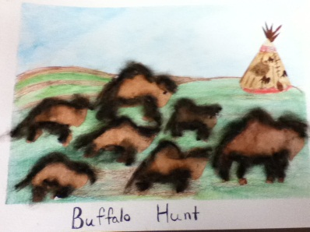
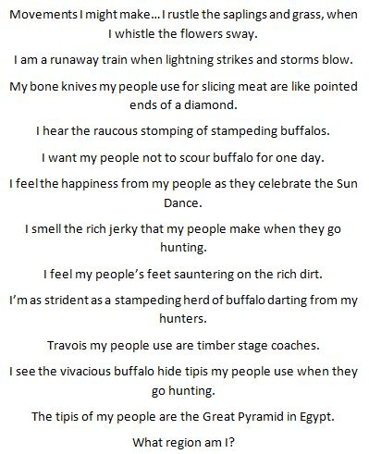
Making a Scene
mixed-media –water color & collage

Art Standards: 4.1.5 Know how different visual art media, techniques, and processes are used to
communicate ideas, experiences, and stories.
Alignment Standards:
Grammar Usage: L5.1, L.5.2
Writing (Informative): W.5.2
Social Studies: 5.5.1

Vocabulary:
Art: texture, space/perspective, envision,
Proportion
Content: impact, natural resources,

Lesson description: Students will apply various brush and water color techniques, as well as collage, to represent a scene. They will learn how collage adds texture to the art piece and reinforces elements within an environment.

Art Elements | Art Principles
☐ Line | ☐ Pattern
☒ Shape/Form | ☒ Rhythm/movement
☐ Color | ☒ Proportion/Scale
☐ Value | ☐ Balance
☒ Texture | ☐ Unity
☒ Space/Perspective | ☐ Emphasis

Artists Habits of Mind:
☐ Engage & Persist
☒ Envision
☒ Express
☐ Observe
☐ Reflect
☒ Stretch & Explore
☐ Understand the Art World
☐ Develop Craft

21st Century Skills:
☐ Global Awareness
☒ Creativity and Innovation
☐ Critical Thinking and Problem
Solving

☒ Communication and Collaboration

☐ ICT Literacy

☐ Flexibility and Adaptability
☒ Initiative and Self-Direction
☒ Productivity and Accountability

☐ Understand the Art World

Grade: 5th Grade
Time: 2 art sessions + writing time
Materials: Watercolor paper, watercolor paints, fan brushes, round brushes, flat brushes, detail brush, thin sharpie marker, blue painters tape for frame, scrap materials (paper, material, sandpaper, yarn, etc)
Lesson 1
Art Component:
Part 1: A Quick Review (20 minutes)
- Begin by reviewing and demonstrating the types of brushes and how they can be used. Do this by sitting at a table or desk and gather students around you.
- Give students “play time” to become reacquainted with the various brushes and techniques.
Part 2: Setting a Scene A (15-20 minutes)
- Show Make A Scene PowerPoint. Discuss what elements they see in each example and have students make inferences about the type of art techniques artists may have used.
- Introduce the students to collage and texture and make references back to the examples on the PowerPoint. Talk about which elements of the scene were collage and which were painting. Have them discuss what added texture to the image and what items may have been used to add the texture.
- Brainstorm a list of scenes.
  - Choose one from the list
  - Talk about where scene might take place and what elements might fit into that scene.
  - Example: Castle—forest with hills and a river—old bricks on the castle, moat, fish in the river, knights, horses, etc.
  - Have students do this same process either independently or with a partner.
Part 3: Setting a Scene B (15 minutes)
- Using the castle scene from above, demonstrate to students what elements of the scene you have chosen to use watercolor (you can also get student input with this task) and paint the background.
- Demonstrate how you would add a collage element, say the castle or a tree made out of a combination of paper and/or fabric.
Part 4: Setting a Scene C (50 minutes)
- Student work time.
- Check to make sure that students are incorporating the techniques you showed them.
- Encourage students to use visual resources to help them “set their scene”.

Part 4: Setting a Scene C (40-50 minutes)
Language Arts: Write an Instant Verb Verse Poem
- Using the following website, create a verb poem using the castle scene created by the teacher: http://ettcweb.lr.k12.nj.us/forms/verbverse.htm
- Students are to create a multi-stanza verb poem. It make this process easier if the scene is broken down into parts, such as one stanza being about the castle, and a second stanza being about the forest, etc.
- The poem really adds a new dimension to the art pieces and makes it “come alive”.
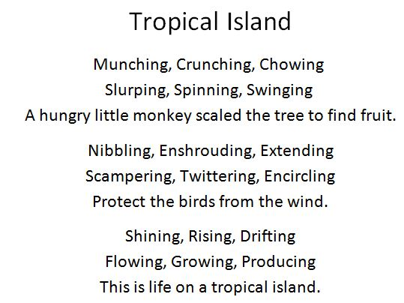

Teacher Background Knowledge
Teachers will need to have an understanding of brush and watercolor techniques. Because students will be creating a collage, teachers will need to have an understanding of the use of texture, perspective, and proportion/scale to represent key features of the environment.

I Cans
Write informative/explanatory texts to examine a topic and convey ideas and information clearly.
Use specific words or phrases and sensory details to describe facts and events in informative writing
Use verb tense to convey various times, sequences, states, and conditions.
Form and use the perfect (e.g., I had walked; I have walked; I will have walked) verb tenses.
Explain the impact of climate, geography, and available resources on the daily lives of Native Americans (e.g., dwellings, clothes, food and crops, technology, tools, cultural traditions)

Use punctuation to separate items in a series.

Preparation:
- Cut watercolor paper into 3 x 3 squares. Each student should have five or six squares.
- Gather enough materials so that either each student has their own set of brushes (fan, detail, round, flat) or every two students share.
- Water color Paint sets can be shared between two people.
- A container for water will be needed (every two people) and everyone should have a paper towel.
- Use blue painters tape to make a frame around the edge of the paper and adhere to the table.
Lesson 2
Art Component:
- Students will follow the same process as described above to create a scene that reflects one of the Native American regions of the United States.
- Make sure you are clear on what elements of the region you want them to depict in their art pieces.
  - Land features
  - Climate
  - Food
  - Transportation
  - Tools, pottery, etc.

Writing Component: Riddle Poem (see student art and writing sample on first page)
For the purpose of a teacher demonstration, choose the Aztec, Incas, or Inuit culture. Use the included guides and organizers to help with the process.
- Begin the process by gathering notes on one of the region.
- As students create sentences and the final riddle poem from their notes, they will speak from the land’s point of view.

Assessment
Source

Name___________________Lesson______________________
Thumbs Down | Don’t Know | Thumbs Up | Assessment Question
 |  |  | Did you use your personal best during this lesson?
 |  |  | Did you actively listen and follow directions?
 |  |  | Did you use your creativity? (is it original?)
 |  |  | Did you complete your project?
 |  |  | Did you incorporate the art media?
 |  |  | Does the artwork show the elements and/or principles discussed?

Region Note-Taking Organizer
Region Studying: _________________________ Name: ___________________
Location  Where: | Shelter  Picture and Name of Home: | Diet  Foods they ate? Be specific  Meat:  Fish:  Fruits:  Vegetables:  Plants:
Land Features & climate | What is the home made from?
Clothing  What did they wear? | Transportation  Types of transportation used:  Materials used to make them: | Arts/Crafts  List at least two –three
What were the clothes made from? | Did they travel in order to get food?
Tools  List at least two - three | Interesting Fact | Interesting Fact

Riddle Poem Brainstorm Guide: EXAMPLE
Answer (the region you are talking about): ___Arctic_______________
Figurative Language
Imagery & Personification
Starter Statement | Your finishing line
I want… | A day where my people do not have to wear fur coats.
I feel… (emotion) | Lonely when my birds migrate
I feel… (physical) | Pain when my people stomp all over me when hunting
I hear… | The crashing of the waves as they slap against my tundra
I see… | In the horizon chunks of ice floating on the sea
I smell… | The salt water on the seals the hunters have caught this day
Movements I might make… | Snow blowing and wind whistling against the igloos

Similes & Metaphors
Simile | Comparing two unlike things using like & as
Simile 1 | My seal’s fur is as warm as a warm fuzzy blanket wrapped around me.
Simile 2 | My peoples’ snow goggles are like broken peanut shells with slits.
Simile 3 | My igloos are as white as a cotton ball.
Metaphor | Comparing two unlike things without using like & as, saying something is something else
Metaphor 1 | My snow-capped mountains are saber- toothed tiger teeth dotting the distant horizon.
Metaphor 2 | My sleds are trains pulled by dogs across the snow and ice.
Metaphor 3 | My climate is a Slushy that never melts.
Vocabulary: Now take some of your more common words and use a thesaurus to “bump them up”.
common words millionaire words
cold | frigid
lonely | isolated
melt | liquefies
warm | inviting
fuzzy | downy ; woolly
blanket | shelter; shell
Poem:
- Must be 8 lines, the 9th line will be” What region am I?”
- Place in order from most difficult clue to the easiest clue
- Aligned in the center of your paper

I feel isolated when my birds migrate.
My snow-capped mountains are saber- toothed tiger teeth dotting the distant horizon.
My climate is a Slushy that never liquefies.
I feel pain when my people stomp all over me to get to their kayaks.
I smell salt water on the walrus the hunters have caught this day.
I want a day where my people do not have to wear fur coats.
My seal’s fur is as warm as an inviting woolly shell wrapped around a turtle.
I hear the crashing of the waves against my tundra.
My sleds are trains pulled by dogs across the snow and ice.
What region am I?
Riddle Poem Brainstorm Guide:
Answer (the region you are talking about): __________________
Figurative Language
Imagery & Personification
Starter Statement | Your finishing line
I want…
I feel… (emotion)
I feel… (physical)
I hear…
I see…
I smell…
Movements I might make…

Similes & Metaphors
Simile | Comparing two unlike things using like & as
Simile 1
Simile 2
Simile 3
Metaphor | Comparing two unlike things without using like & as, saying something is something else
Metaphor 1
Metaphor 2
Metaphor 3

Vocabulary: Now take some of your more common words and use a thesaurus to “bump them up”.
common words millionaire words
Poem:
- Must be 8 lines, the 9th line will be” What region am I?”
- Place in order from most difficult clue to the easiest clue
- Aligned in the center of your paper

