Loo
Roosevelt
Elementary
SALT Integrated
Lesson Plan

Content Connections:
Health: Emotions; Senses
Language Arts: thesaurus; word meaning; metaphors; similes
Writing: Senses Poem
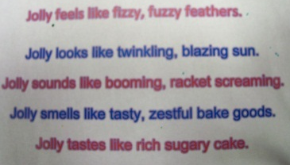
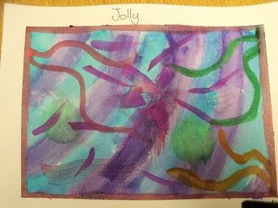
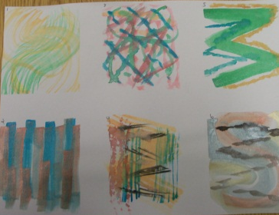
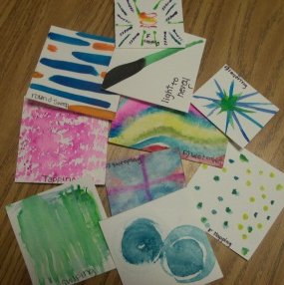
Vocabulary:
Art: wet on wet, flat brush, round brush, fan brush, detail brush
Content: metaphor, simile, assigned emotions
Lesson description:
Students will learn and apply various brush and water color techniques to represent emotions.

Art Standards: 4.1.5 Know how different visual art media, techniques, and processes are used to
communicate ideas, experiences, and stories.
Alignment Standards:
Vocabulary Focus: L5.4, L.5.5, L5.6
Writing (Sensory Detail): W.5.3d
Grade: 5th Grade
Time: 2 art sessions + writing time
Materials:
Watercolor paper, watercolor paints, fan brushes, round brushes, flat brushes, detail brush, thin sharpie marker, and blue painters tape for frame

Art Elements | Art Principles
☒ Line | ☒ Pattern
☐ Shape/Form | ☒ Rhythm/movement
☒ Color | ☐ Proportion/Scale
☐ Value | ☐ Balance
☐ Texture | ☐ Unity
☐ Space/Perspective | ☐ Emphasis

21st Century Skills:
☐ Global Awareness
☒ Creativity and Innovation
☐ Critical Thinking and Problem
Solving

☐ Communication and Collaboration

☐ ICT Literacy

☐ Flexibility and Adaptability
☒ Initiative and Self-Direction
☐ Productivity and Accountability

☐ Understand the Art World

Artists Habits of Mind:
☒ Engage & Persist
☒ Envision
☒ Express
☒ Observe
☐ Reflect
☐ Stretch & Explore
☒ Understand the Art World

Inside A Word
Teacher Background Knowledge
Teachers will need to have an understanding of brush and watercolor techniques. It is with this knowledge that students will be able to represent their emotion with the use of lines.
Lesson
Art Component:
Part 1: Watercolor Swatches (30-40 minutes)
- Begin by introducing the types of brushes students will be using, then give a demonstration of what each of the brushes can do, as well as, the wet on wet technique. Do this by sitting at a table or desk and gather students around you.
- Each brush or technique you demonstrate should be done on a swatch and labeled. This will provide an example for the students.
- Hand out the swatches, brushes, paints, water and paper towel to students.
- Have students label (use sharpie marker) the type of brush or technique on each of the swatches before they paint.
- Give students time to make their swatches and explore with the various brushes and techniques.
Part 2: Mood Music (20-30 minutes)
- Once students have made their swatches and had some exploration time, hand out a full-sized piece of watercolor paper.
- Demonstrate how to make six boxes using the blue painters tape.
- Students will now use the techniques they learned from watercolor swatches to express thoughts, feelings, emotions, images they get when they listen to six different styles of music.
- As each style of music is played, follow these procedures:
  - Listen to the music only for about 30 seconds
  - Play the music again, giving students time to paint lines, shapes, images and color to reflect their thoughts and feelings as they tune in to the music. (about 2 minutes)
  - Briefly, have students share what they created getting them to share their thoughts about the music and how their art reflects that style.
  - Continue until all music pieces have been played.
Part 3: Inside a Word (50-60 minutes)
- Read Red-Yellow-Blue Colors in Art by Silke Vry and discuss how the use of different color and lines can show emotion.
- Start with students painting their background (it needs to dry). The background colors should blend and be subtle.
- Introduce samples/images of abstract art. Discuss features (similarities) of the samples or images. Explain that this style of art is called abstract art. Make generalizations about why these art pieces are abstract (get students to come up with the definition through observation and discussion).
- Show examples of work by Abstract Expressionists.
- Prior to this final lesson, students would have studied and written about a specific emotion (see section lesson below)
- Students will use this information to create an abstract art piece of their emotion. They will use colors, lines, and techniques, and various brushes to reflect the meaning of their word.

Preparation:
- Cut watercolor paper into 3 x 3 squares. Each student should have five or six squares.
- Gather enough materials so that either each student has their own set of brushes (fan, detail, round, flat) or every two students share.
- Water color Paint sets can be shared between two people.
- A container for water will be needed (every two people) and everyone should have a paper towel.
- Use blue painters tape to make a frame around the edge of the paper.
I Cans
Use specific words or phrases and sensory details to describe experiences and events in narrative writing
Choose a variety of words that effectively state purpose or intent
Use reference materials to determine word meanings and pronunciation
Identify synonyms, antonyms, and homographs

Language Arts: Writing (sensory detail) (use “Fill your Senses” flipchart)
- Review the five senses. Listen to a really dramatic piece of music or a variety of sound effects. As a class, analyze it through what they hear, see, feel, smell, touch, taste. See examples below:
  - Hear: moans, laughter, screams, howling, etc.
  - Smell: musty, dusty (dry), sweat, smoky, etc.
  - Feel: wet, rough, pointy, vibrating, etc.
  - See: shadows, fire, darkness, animals, etc.
  - Taste: sour, salty, sweet, etc.
- Choose an emotion to use as a model for what students will be doing independently.
- As a class, become familiar with the word by…
  - looking up the meaning of the word,
  - finding synonyms of the word, and
  - recording this information on paper or electronically.
  - studying the synonyms and determine which sense the word relates to most.
- Powerful Sentence creation
  - Brainstorm descriptive words using adjectives that talk about sound, taste, smell, touch, and sight. These words will help set the “mood” for the painting.
  - It is also helpful to brainstorm things (items) that fit with the word in each category.
- Using the descriptive words as described above, students will create a five senses poem in the following format:
FRIGHT
Fright looks like a dungy, shaking chainsaw.
Fright tastes like foul, putrid rotten eggs.
Fright feels like jagged, sharp edges.
Fright sounds like ear-popping, wicked laughter.
Fright smells like a smoky, musty basement.

Assessment
Source

Name___________________Lesson______________________
Thumbs Down | Don’t Know | Thumbs Up | Assessment Question
 |  |  | Did you use your personal best during this lesson?
 |  |  | Did you actively listen and follow directions?
 |  |  | Did you use your creativity? (is it original?)
 |  |  | Did you complete your project?
 |  |  | Did you incorporate the art media?
 |  |  | Does the artwork show the elements and/or principles discussed?

- Calm
- Harmonious
- Mellow
- Peaceful
- Quiescent
- Serene
- Confused
- Baffled
A list of Emotions
- Bewildered
- Dazed
- Perplexed
- Mystified
- Lively
- Animated
- Thrilled
- Chipper
- Ecstatic
- Gleeful
- Jolly
- Jubilant
- Peppy
- Upbeat
- Secluded
- Jittery
- Skittish
- Dignified
- Crestfallen
- Forlorn
- Cautious
- Demure
- Coy
- Awestruck
- Flabbergasted
- Shocked
- thunderstruck

Emotion Writing Organizer
Emotion
Definition of the word
List of synonyms
List Five Senses | Touch | Taste |  | Smell |  | See |  | Hear
Organize synonyms
above to fit under
a specific sense.
Things that reflect
this sense…

Five Senses Poem
(Emotion word) looks like
Tastes like
Feels like
Sounds like
Smells like

