BPS Art Curriculum

Favorite Food Soft Sculpture
Art Standards:
8.1.1, 8.1.2, 8.1.3, 8.1.5, 8.1.6, 8.2.1, 8.3.1, 8.5.1
Alignment Standards:
ELA 5.2.1, 5.3.1, 5.3.3, 5.3.11
Materials: Markers, colored pencils, crayons, pencils, scissors, staples, stapler, scrap paper to stuff sculpture and white bulletin board paper of 3 to 4 feet in length per student or pair of students.
Grade: Fifth Grade
Time: 2 - 3 Class Periods
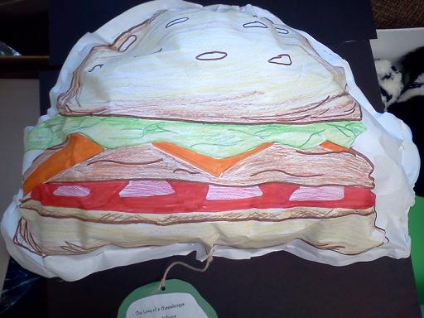Ins
Content Connections:
English Language Arts

Art Elements | Art Principles
__Line | __Pattern
_X_Shape/Form | __Rhythm/movement
_X_Color | _X_Proportion/Scale
__Value | __Balance
__Texture | __Unity
__Space/Perspective | __Emphasis

Preparation:
Have a 3 to 4 foot length of bulletin board paper available for each student or pair of students.
Provide enough scratch paper available to stuff sculptures.
Vocabulary: sculpture and proportion

I Cans/ Objectives:
I can create a soft sculpture of my favorite food.
I can color my sculpture to replicate my favorite food.
I can write a poem about my sculpture.

Lesson :
- Read food poems such as “Spaghetti, Spaghetti” by
Jack Prelutsky and “On top of Spaghetti” by Ken Nesbitt and Donna Lee Murphy.
- Have students brainstorm their favorite foods; choose one to draw on the large bulletin board paper.
- Before drawing, students should fold their bulletin board paper in half.
- Students begin by drawing their favorite food on one side of their bulletin board paper. (If you would like the sculptures to be a mobile students can replicate their drawing on the back side.)
- Next, students color their food drawings with a variety of coloring utensils such as markers, crayons, and colored pencils.
- Once students have finished coloring they begin to staple the two sides together around the outer edge leaving an opening to stuff their drawings. Once it is stuffed to desired level finish by stapling the food sculpture shut.
- Students can begin brainstorming adjectives or fun phrases about their food they could use when writing their poem.

Teacher Background Knowledge:
Teacher may choose to staple the sculptures to the wall and display student poetry beside their sculpture. You may choose to hole punch the bottom of the sculpture and hang poetry from the bottom of the sculpture in order to create mobile.
Lesson description:
Students will create a soft sculpture of their favorite food and write a descriptive poem to accompany their sculpture.
Name___________________Lesson______________________
Assessment
Thumbs Down | Don’t Know | Thumbs Up | Assessment Question
 |  |  | Did you use your personal best during this lesson?
 |  |  | Did you actively listen and follow directions?
 |  |  | Did you use your creativity? (is it original?)
 |  |  | Did you complete your project?
 |  |  | Did you incorporate the art media?
 |  |  | Does the artwork show the elements and/or principles discussed?

