BPS Art Curriculum

Tuesday
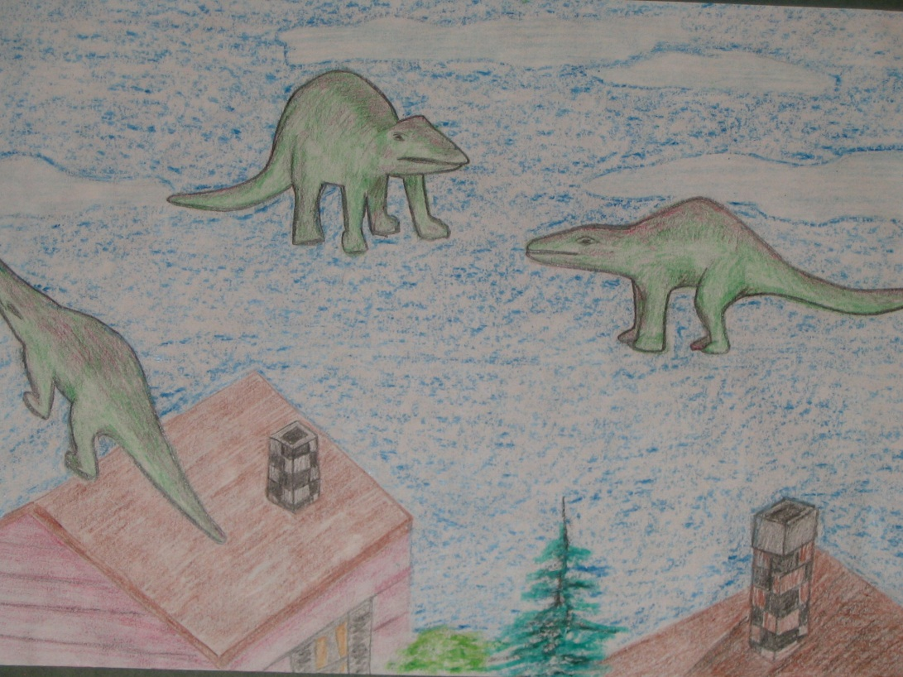
Content Connections:
Reading
Children’s Literature
Caldecott Honor Book
Art Standards: 8.1.1, 8.1.2, 8.1.3, 8.1.4, 8.1.5, 8.1.6, 8.2.1, 8.2.2, 8.3.1, 8.5.1, 8.5.2, 8.6.1, 8.6.2

Alignment Standards: ELA 5.2.1, 5.3.1, 5.3.3
Materials:
Drawing Paper
Colored Pencils, Crayons or Markers
Small plastic animals

Art Elements | Art Principles
_x Line | __Pattern
_x Shape/Form | _x Rhythm/movement
_x Color | _x Proportion/Scale
__Value | _x Balance
_x Texture | _x Unity
_x Space/Perspective | __Emphasis

Grade: 5th

Time:
Preparation
Find and present the book, “Tuesday” by David Wiesner.
Brainstorm unlikely things that can fly through the air.

Vocabulary
Balance, Line, Shape, Color, Illustration

I Cans/ Objectives
- I can select and draw an animal from every angle.
- I can draw the animal in a variety of sizes and from a variety of viewpoints.
- I can draw the tops of trees, houses, and buildings along the bottom 2 inches of the paper.
- I can color the drawing with colored pencils, crayons or markers to create a feeling of objects floating in the sky.

Lesson description
Students will create a dreamlike illustration of something doesn’t happen (surreal).
Teacher Background Knowledge
David Eisner, the author of, “Tuesday” won the Caldecott Medal for illustrating the book in 1992.
Lesson
- Students select an animal to draw and examine it closely from every angle-top, bottom, front, back, and side.
- On the paper, practice drawing the animal from a variety of view points and in a variety of sizes.
- On the drawing paper, draw the animal in a variety of sizes and from a variety of viewpoint. Overlap some of the animals.
- Draw the tops of trees, houses, and buildings along the bottom 2 inches of the paper.
- Color the drawing with colored pencils or markers. To create the feeling of objects floating in the sky, completely color the background in sky colors and add stars, clouds, sun and/ or moon.
- Encourage students to use the side of the colored pencil lead rather than the point itself when coloring large areas such as the sky.
Name___________________Lesson______________________
Assessment
Thumbs Down | Don’t Know | Thumbs Up | Assessment Question
 |  |  | Did you use your personal best during this lesson?
 |  |  | Did you actively listen and follow directions?
 |  |  | Did you use your creativity? (Is it original?)
 |  |  | Did you complete your project?
 |  |  | Did you incorporate the art media?
 |  |  | Does the artwork show the elements and/or principles discussed?

Teaching Art with Books Kids Love: Art Elements, Appreciation, and Design with Award-winning Books, Frohart, Darcie Clark, Fulcrum Publishing, Golden, Colorado, 1999.

