BPS Art Curriculum

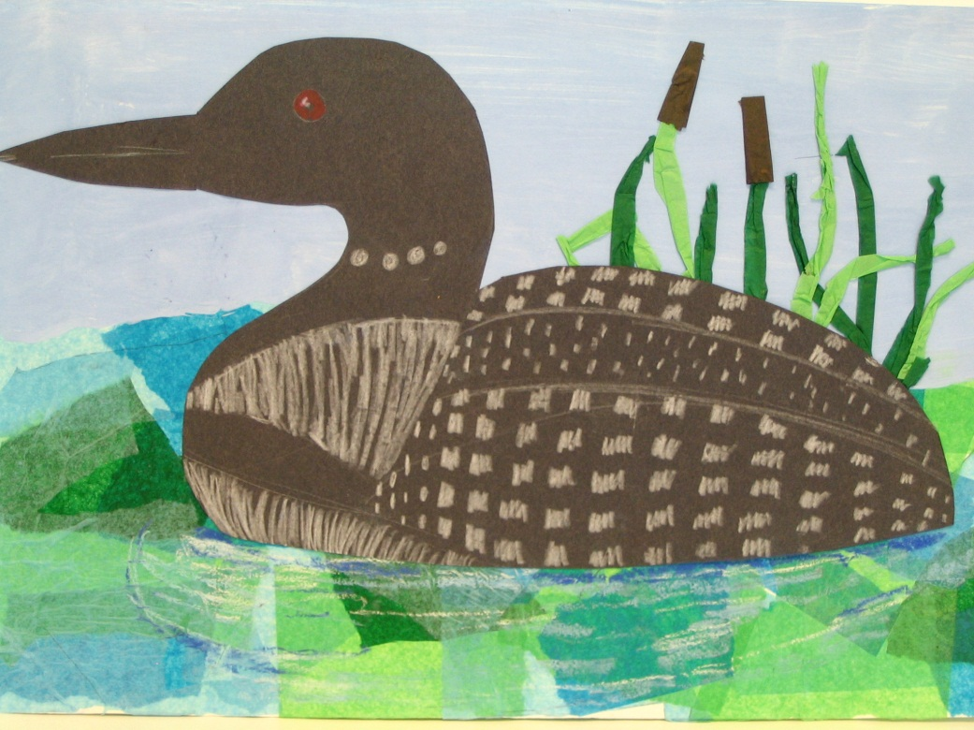
Materials:
Pencils
12”x18” drawing paper
12”x18” black construction paper
Blue and white Tempera Paint
Containers for mixing Tempera Paint
Brushes
Black Crayon
Scissors
Tissue paper in blues and greens and brown
Bottled White Glue
Containers for mixing glue and water
Chalk pastel in white and blue
White and red crayons

Art Standards: 8.1.1, 8.1.2, 8.1.3, 8.1.5, 8.1.6, 8.2.1, 8.3.1, 8.5.1

Science:
Grade: 5th

Time:

Art Elements | Art Principles
_x Line | _x Pattern
_x Shape/Form | __Rhythm/movement
_x Color | _x Proportion/Scale
__ Value | _x Balance
__Texture | _x Unity
_x Space/Perspective | __ Emphasis

Content Connections:
Science

This project can be adapted to different core subjects and the subject matter and habitat can change to fit the subject.
Waterfowlin the Wild
Preparation
- Tear blue and green tissue paper into small pieces.
- Cut green tissue into rectangles that would be the appropriate size to roll for the stems of the cattails.
- Cut brown tissue into rectangles than would be appropriate size to roll for the brown fuzzy portion of the cattails.
- Find reference photos of loons or the waterfowl you would like the students to create.
- Mix glue and water for the collage portion. Two parts glue to one part water.
Vocabulary
Foreground, Middle Ground, Background, Collage.

I Cans/ Objectives
- I can designate foreground, background and middle ground on my project.
- I can mix a tint to make light blue.
- I can use a collage technique with tissue paper to form the water section of the artwork.
- I can use basic shapes to draw a loon or other waterfowl.
- I can roll and manipulate tissue paper to look three dimensional and represent cattails.

Lesson description
Create a life-like piece of artwork that has a loon or waterfowl as its subject matter. Students will use multiple forms of media and techniques.
Teacher Background Knowledge
Research what waterfowl you would like your students to create. Have reference photos available for them.

Tint – a color to which white has been added
Foreground – the part of a drawing or painting that appears closest to the viewer.
Middle ground – in a representational picture, the area that is neither closest to, or farthest from, the viewer – the space between the foreground and background
Background – the far distance in a landscape painting. The space immediately behind the subject in a portrait or still life. The space around a subject in a picture and in the same plane as the subject.

Lesson
- Hand out white drawing paper. Have students lay the paper the landscape way. Discuss foreground, middle ground and background. Have them draw a light horizontal line in the middle of their paper.
- Discuss that when color is added to white, it is called a TINT. Demonstrate how to mix a tint of blue for the sky. Have students mix a tint of blue and paint the upper half of their paper down to the horizontal line. Set aside to dry. This is their background.
- Demonstrate how to create the collage portion on the bottom half of the paper. Start by painting the glue mixture on a small area of the drawing paper. Lay tissue on top of the wet area and apply more glue over the top. Overlap tissue pieces as you layer. Don’t let the white paper peek through. Set aside to dry. This is the foreground.
- Discuss how to draw the shape of the loon or waterfowl from basic shapes. See diagram of attached sheet. Students should lightly draw their bird on the black construction paper and cut out.
- Have students draw any prominent markings on the bird with pencil (ie eyes, feathers, stripes etc.). When these lines are where the artists want them, they should trace over the lines with white crayons. A red crayon can fill in the eye shape.
- Demonstrate how to roll the tissue and bend it so that it looks like cattails. Have students glue the tissue for the cattails in the middle ground.
- Students can then glue the bird in the middle ground. Overlap the bird on top of the cattails so that they stick out above the bird.
- Using oil pastels, draw blue and white curved lines below the bird to represent ripples in the water.
Name___________________Lesson______________________
Assessment
Thumbs Down | Don’t Know | Thumbs Up | Assessment Question
 |  |  | Did you use your personal best during this lesson?
 |  |  | Did you actively listen and follow directions?
 |  |  | Did you use your creativity? (is it original?)
 |  |  | Did you complete your project?
 |  |  | Did you incorporate the art media?
 |  |  | Does the artwork show the elements and/or principles discussed?

How to draw the loon using basic shapes:

After drawing the basic shapes connect them using a smooth outer line.

