Step 1
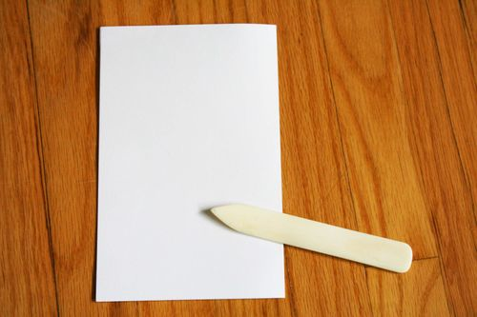
Using a bone folder (or a sturdy popsicle stick) fold a piece of card stock in half. Use the folding tool to make sure that your crease is smooth and sharp. This piece of card stock will become the binding of your book.

Step 2
Now, open the piece of card stock back up and fold each half of the card stock in half again (fold toward the middle).
Step 3
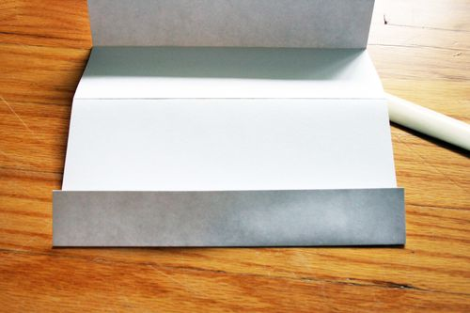
Open the card stock up again. It should now be folded into fourths. Fold the section closest to you in half again.
Step 4
Now turn the card stock over, and fold the next section (moving towards the middle) in half as well. You are basically going to keep turning the card stock over and each time you turn it, fold the next fourth in half again so that the entire piece is folded accordion style into eighths.
Step 5
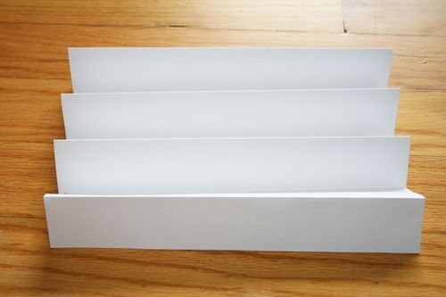
When you are finished folding the card stock accordion-style, it should look like the picture above. At this point I should probably mention that every time I type the word "accordion," I think about how Mariam is always telling me that she wants to grow up to be a crossing guard who plays the accordion. Moving on...
Step 6
Cut another piece of card stock in half so that it now measures 5 1/2" by 8 1/2". Take the folded piece of card stock and glue the half-piece onto the first accordion on the outside. This will make your front cover.
Step 7
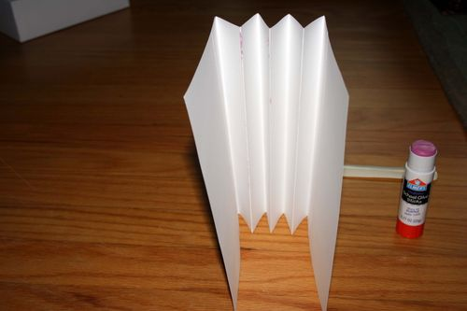
Do the same with the outside of the final accordion so that you now have both a front and back cover attached to your accordion binding.
Step 8
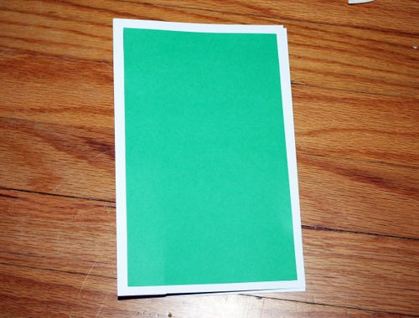
If it suits your fancy, you can also now glue a slightly smaller piece of colored paper to the front and/or back cover. It suited my fancy, so I did this here. I cut the colored paper to be about 4 1/2" by 8". I then (sort of) centered it and glued it onto the half sheet of card stock.
Step 9
Next, cut two pieces of colored paper so that they are the same size as the card stock cover pieces (5 1/2" by 8 1/2"). Glue them to the backs of the front and back covers, sandwiching the first and last accordion folds inside.
Step 10
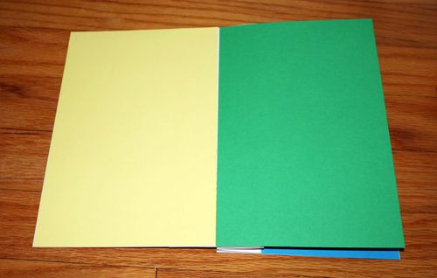
Now you will make the pages for the inside of the book. Take another half-sheet of colored paper (again 5 1/2" by 8 1/2") and glue it to the front side (the one facing the front cover) of the next accordion fold.
Step 11
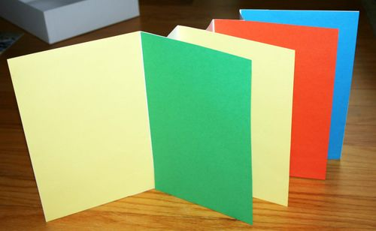
Do the same with two more half-sheets of colored paper, gluing each to the front side of the next two accordion folds. The backs of each fold will be left blank (just the folded card stock). You now have the "skeleton" of your book!

