Caterpillar Books
1. Cut paper into 4 x 4 inch sheets. The end booklet will be 2 x 2 inches. Any size will work, as long as it is square and all sheets are the same size. You can make the booklet any number of sheets. I will show how to put 2 together, but my end result is 5 sheets long.
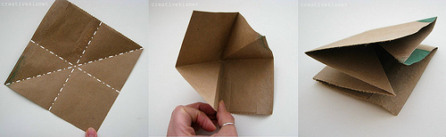
2. Fold each sheet in half both ways and in half diagonally. Pull diagonal fold inward as seen in photo. Repeat with all sheets.
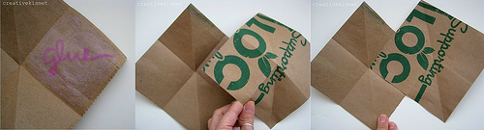
3. Glue sheets together, with glue stick, so that one sheet folds inward and the other outward. Continue adding more sheets if desired.
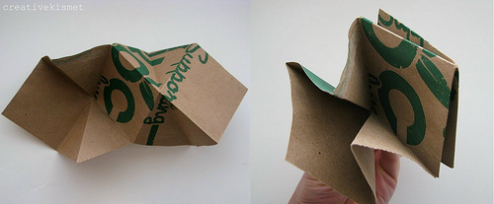
4. Fold booklet closed, carefully creasing each fold with your nail or bone folder.
5. Open and decorate whatever way you see fit.
