Graduated Book
Step 1. Decide how many layers you are going to make. Then, cut your paper down the middle- you can use regular paper (8 ½" by 11") or construction paper. Cut as many pieces as you need to make the number of layers you want. You can make each page the same, or you can change colors for each layer!
Step 2. Lay all the papers together, with the top edges lined up. Staple along the top edge.
Step 3. Start with the next to last page. The bottom of the next ot the last page should be about 1/2" or 1" shorter than the last page. Then the next page is 1/2" or 1" shorter than this page. This continues until you get to the top page! (So, if your paper is 11" long, the next piece is 10", the next is 9", the next is 8"...until you get to the last page.)
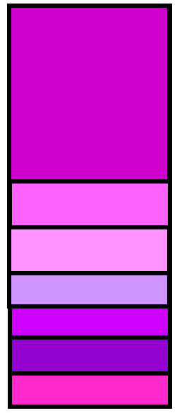
Step 4. You can use your book for lots of different projects. You could make 9 pages and do a page for each planet of the solar system, or you could write direction of how to do something - where each page is the next step. You can punch a hole in the top and tie the hole with a string of yarn tied in a bow to hang your graduated book up.
