**Paper Bag Books**

[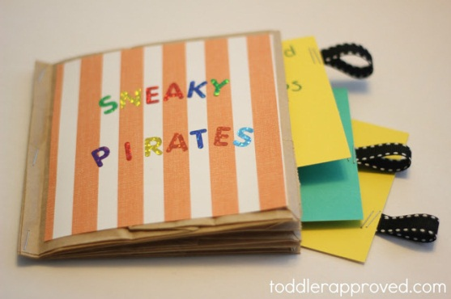](http://4.bp.blogspot.com/-BHWJHdRqDYA/T6i3UJwxNoI/AAAAAAAA-lE/AP2bJPty7Zw/s1600/sneaky+pirates.jpg)

[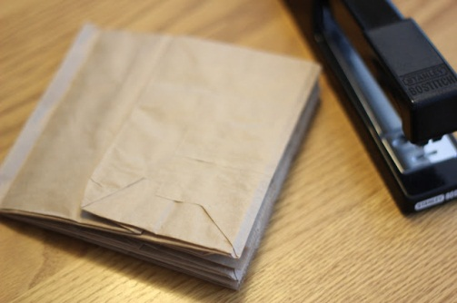](http://2.bp.blogspot.com/-wyEJSDakQuY/T6i5pxWxwLI/AAAAAAAA-lM/qWq-_wGrHKA/s1600/IMG_9151.JPG)

[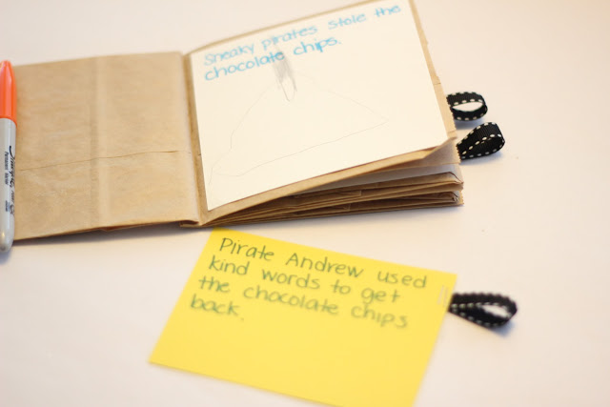](http://4.bp.blogspot.com/-QVaxFnJmeVg/T6i7fY8fUXI/AAAAAAAA-lc/qFA3qfogaj0/s1600/IMG_9157.JPG)