Pop-up books
Construct the pop-up page by folding it in half on the fold line.
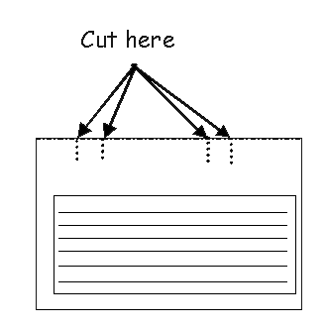
Cut the dashed lines to make the tabs. Fold the tabs down.
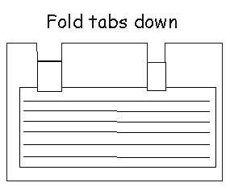
Then unfold the pop-up page and push the tabs forward.
