**[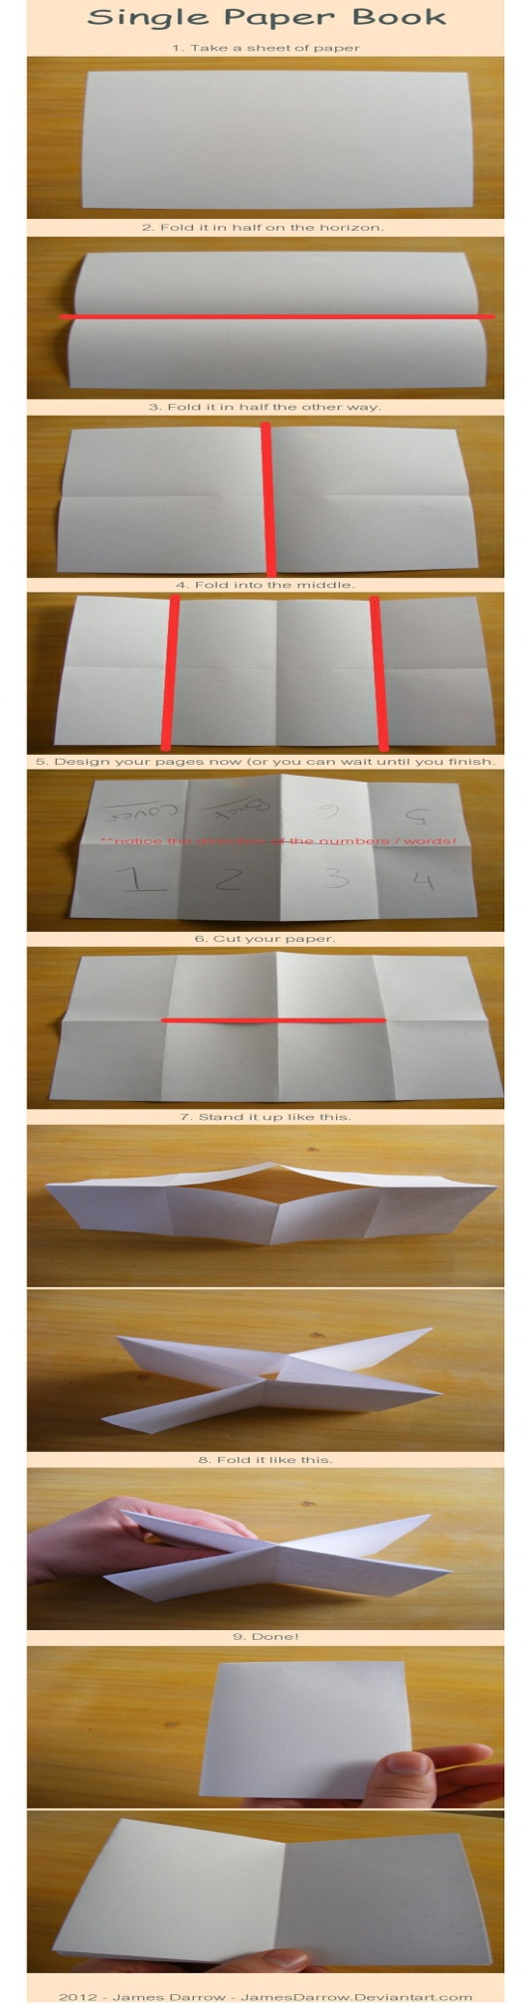](http://browse.deviantart.com/?qh=&section=&global=1&q=single+paper)**