Name Date Class


INTERPRETING GRAPHICS
Use with Section 2.3

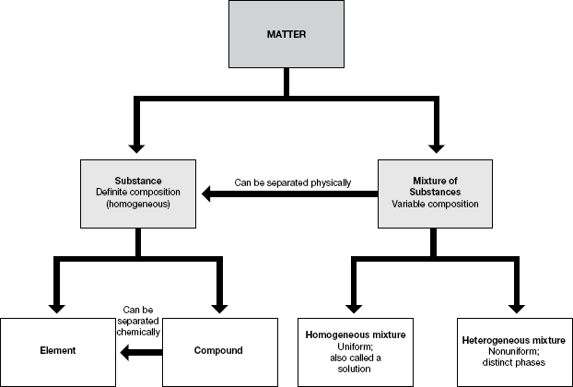

Chapter 2 Matter and Change 41
Name Date Class

Use the flowchart on the previous page, redrawn from Figure 2.8 in your textbook, to answer the following questions.

1. Motor oil is available in various grades (10W30, 10W40, and so on). Is motor oil homogenous mixture or a compound? Explain.

2. Iron ore is a heterogenous mixture that contains iron oxide. Iron ore can be smelted to produce pure iron. Is iron smelting a chemical or physical process? Explain.

3. Classify each of the following as physical or chemical separations.
a. air →oxygen + nitrogen

b. water →hydrogen + oxygen

c. salt water →water + sodium chloride

4. Classify each of the following as mixtures or substances.
a. sulfur

b. air

c. concrete

d. water

42 Core Teaching Resources

