Name Date Class


INTERPRETING GRAPHICS
Use with Section 3.2

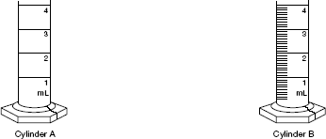

Figure 1

Use Figure 1 to answer the following questions.
1. Cylinder A is used to measure liquids up to 4 mL. To what number of significant figures could liquids be measured using cylinder A?

2. Cylinder B is also used to measure liquids up to 4 mL. To what number of significant figures could liquids be measured using cylinder B?

3. A student is asked to measure out 2.55 mL of water. Which cylinder(s) would be suitable for this measurement?

4. A student is asked to measure out 3 mL of methanol. Which cylinder(s) would be suitable for this measurement?

66 Core Teaching Resources
Name Date Class

Figure 2

Figure 2 shows a thermometer that is calibrated in both Celsius and Kelvin scales. Use Figure 2 to answer the following questions.
5. Which temperature scale is shown at the top of the drawing?

6. Which temperature scale is shown at the bottom of the drawing?

7. A student reported the temperature shown to be 20°C. Is this the correct number of significant figures? Why?

8. In what physical state does water exist at the temperature shown?

Chapter 3 Scientific Measurement 67

