Name Date Class

INTERPRETING GRAPHICS
Use with Section 9.1

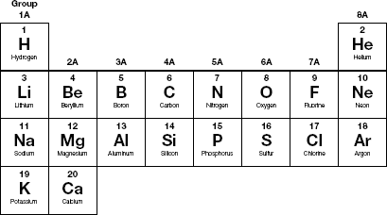

Use the abbreviated periodic table above to answer the following questions.
1. Which group on the periodic table contains magnesium (Mg)?

2. How many electrons does a magnesium atom lose to form a magnesium cation?

3. How many electrons does a neutral magnesium atom contain?

4. How many electrons does a magnesium cation contain?

5. Which group on the periodic table contains fluorine (F)?

6. How many electrons does a fluorine atom gain to form a fluoride anion?

7. How many electrons does a neutral fluorine atom contain?

224 Core Teaching Resources
Name Date Class

8. How many electrons does a fluoride anion contain?

9. How many electrons does a sodium cation contain?

10. How many electrons does an oxide anion contain?

11. How many electrons does each of the following ions contain?
a. S^{2–}
b. Ca²⁺
c. K⁺
d. Cl–

Chapter 9 Chemical Names and Formulas 225

