Name Date Class


INTERPRETING GRAPHICS
Use with Section 10.3

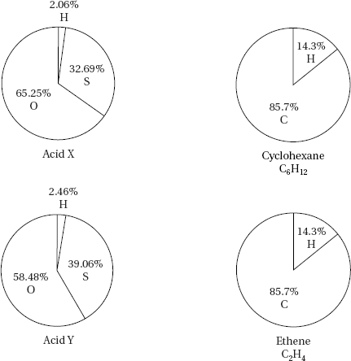

Use the circle graphs above to answer the following questions.
1. What is the percent of carbon in 50.0 g of cyclohexane?

2. Calculate the mass of hydrogen in 150.0 g of ethene.

3. Using the circle graphs, explain why percent composition alone is not sufficient to distinguish one compound from another.

Chapter 10 Chemical Quantities 249
Name Date Class

4. What information, in addition to percent composition, is needed to distinguish ethene from cyclohexane?

5. Scientists can use reactivity as a means of distinguishing between compounds with the same empirical formula. Ethene reacts with bromine to form dibromoethane, C₂H₄Br₂. Cyclohexane does not react with bromine. Create a circle graph to show the percent composition of dibromoethane.

6. Which of the circle graphs, labeled Acid X and Acid Y, represents the percentage composition of sulfuric acid, H₂SO₄? Which represents the percentage composition of sulfurous acid, H₂SO₃?

250 Core Teaching Resources

