Name Date Class


INTERPRETING GRAPHICS
Use with Section 16.1

Solubilities of Some Substances in Water at Various Temperatures
 |  | Solubility (g/100 g of H₂O)
Substance | Formula | 0°C | 20°C | 50°C | 100°C
Barium hydroxide | Ba(OH)₂ | 1.67 | 31.89 | — | —
Barium sulfate | BaSO₄ | 0.00019 | 0.00025 | 0.00034 | —
Calcium hydroxide | Ca(OH)₂ | 0.189 | 0.173 | — | 0.07
Lead(II) chloride | PbCl₂ | 0.60 | 0.99 | 1.70 | —
Lithium carbonate | Li₂CO₃ | 1.5 | 1.3 | 1.1 | 0.70
Potassium chlorate | KClO₃ | 4.0 | 7.4 | 19.3 | 56.0
Potassium chloride | KCl | 27.6 | 34.0 | 42.6 | 57.6
Sodium chloride | NaCl | 35.7 | 36.0 | 37.0 | 39.2
Sodium nitrate | NaNO₃ | 74 | 88.0 | 114.0 | 182
Sodium sulfate | Na₂SO₄ | 4.76 | 62 | 50.0 | 41.0
Silver nitrate | AgNO₃ | 122 | 222.0 | 455.0 | 733
Lithium bromide | LiBr | 143.0 | 166 | 203 | 266.0
Cane sugar (sucrose) | C₁₂H₂₂O₁₁ | 179 | 230.9 | 260.4 | 487

A portion of Table 16.1 from your textbook has been reproduced above. Use the table to answer the following questions.
1. Saturated solutions of each of the following compounds are made at 20°C. Circle the letter(s) of the solution(s) that will form a precipitate upon heating.
a. NaCl c. Li₂CO₃
b. Na₂SO₄ d. sucrose
2. A saturated solution of potassium chloride is prepared in 100.0 g of water at 20°C. If the solution is heated to 50°C, how much more KCl must be added to obtain a saturated solution?

Chapter 16 Solutions 409
Name Date Class

3. A saturated solution of sucrose in 1000.0 g of boiling water is cooled to 20°C. What mass of rock candy will be formed?

4. Using data from the table, plot the solubility curves of KCl, LiBr and Na₂SO₄ on the graph below. Be sure to label each curve. Use the graph to answer the following questions.
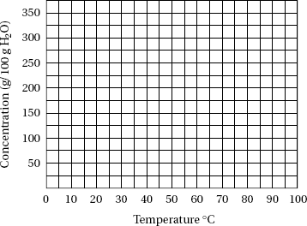

a. Which of the compounds is most soluble at 25°C?

b. Which of the compounds has the lowest solubility at 90°C?

410 Core Teaching Resources

