Name Date Class


INTERPRETING GRAPHICS
Use with Section 8.3

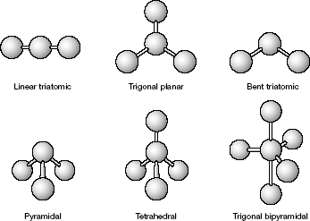

Figure 1 Common Molecular Shapes

Use what you have learned in Chapter 8 to complete the table on the following page.
Table 1 Arrangement of electron pairs about an atom
Number of valence electron pairs about the central atom | Arrangement of valence-electron pairs
2 | linear
3 | trigonal planar
4 | tetrahedral
5 | trigonal bipyramidal

192 Core Teaching Resources
Name Date Class

Table 2 Molecular Geometries
Molecule | Electron Dot Structure | Shape | Bond Angle | Resonance Structures
1. CO₂
2. CH₄
3. SO₃
4. BeF₂
5. PF₃
6. PCl₅
7. H₂O

8. If you have access to a molecular model set, construct three-dimensional models of each of the molecules in the table. Compare your models to the shapes shown in Figure 1. With a protractor, measure all the bond angles in your models. Compare these angles to those predicted by VSEPR theory and label each of the illustrations in Figure 1 with the correct bond angles.

Chapter 8 Covalent Bonding 193

