CHAPTER 12 – CHEMICAL BONDING

- Bond formation
- electronegativity – tendency for atoms to attract e⁻ when combined
- scaled by comparing w/ other atoms
- most active metals = lowest electronegativities
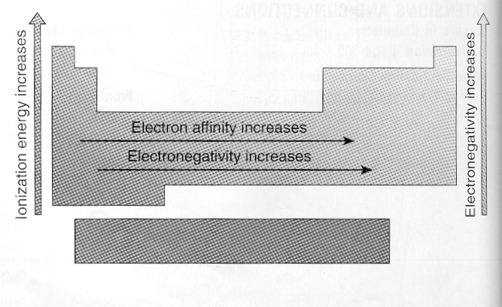
- chemical bond strength
- diff. in e⁻ neg.
- bond strength: 568.1 kJ/mol
e⁻ diff.: 1.90
2) b.s.: 298.32 kJ/mol
e.d.: 0.01
- bond character
- e⁻ transferred when e⁻ neg. diff. is high
- diff. is small: e⁻ shared instead
- e⁻ is not constant, changes w/ combination of atoms
- changes w/ # of atoms it combines w/
- ionic bond – 2 elements combine by e⁻ transfer
- covalent bond – share e⁻
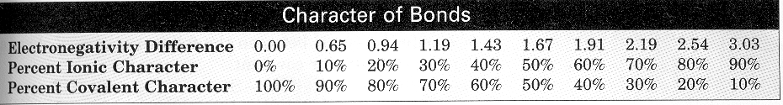
- how do we know which is which?

Examples:
Mg – O: [3.50 – 1.23] = 2.27
B – P: [2.01 – 2.06] = 0.05
Be – Si: [1.47 – 1.74] = 0.27
C – Na: [2.50 – 1.01] = 1.49
Li – O: [0.97 – 3.50] = 2.53
Mg – N: [1.23 – 3.07] = 1.84

- ionic bonds
- high melting pts.
- conduct in molten state
- soluble
- crystallize – sharply defined particles
- NaCl
- covalent bonds
- formed betw. nonmetals
- low melting pts.
- do not conduct
- brittle

- covalent bond forms molecule
- bond axis – line joining 2 nuclei
- bond angle – 3 atoms; angle betw. 2 bond axes
- bond length – distance betw. nuclei in bond axis (varies)
- motions
- bending
- rotating
- symmetrical stretching
- asymmetric stretching

internuclear distance;
bond axis;
bond length
ionic radius
Van der Waals
radius

Van der Waals radius > covalent/ionic radius

Bond length approx. = sum of individual radii (usually a
little less)
II. Particle sizes
A. Ionic radii
1. anion (- ion) > stable atom
2. cations (+ ion) < stable atom
3. adding radii of 2 ions in cmpd =
internuclear distance in crystal
B. Covalent radii
1. consider: Cl₂ + I₂ → 2ICl
internuclear dist. Cl₂ = 199 pm; ½ = 99.5
id I₂ = 266 pm; ½ = 133
(99.5 + 133) = 233 pm
2. van der Waals radius
a. minimum distance of non-bonded
atoms
1) e⁻ clouds repel ea. other
b. greater than covalent radius, for
bonded side is sharing e⁻
1) “squishing” cloud on that side
C. summary of radii
1. atomic
a. measured on atoms in crystals
2. ionic
a. diff due to gain/loss of e⁻
3. covalent
a. < atomic due to sharing e⁻
b. may be > if multiple atoms
4. van der Waals
a. should be around same as atomic

D. summary of bond types

