**Chapter 6 Study Guide: Integumentary System Name ____________________**

1. **Short Answer**
2. Thin skin is a type that has relatively little stratum ________________.
3. The majority of cells in the epidermis are a type called ____________________.
4. An epidermal cell involved in the sense of touch is called a _________________ cell.
5. Dead cells of the epidermal surface are said to ______________ as they flake off.
6. The epidermis cannot slide freely over the dermis because of projections of dermis called _____.
7. A bruise is also called a/an ______________________.
8. The action of ultraviolet light on dehydrocholestrerol circulating through the skin is the first step in the synthesis of _________________.
9. When it is cold, cutaneous __________________ helps retain heat by reducing blood flow through the skin.
10. ________________ is the removal of eschar from burned skin.
11. The oily secretion of the scalp comes from the ___________ glands associated with hair follicles.
12. A _________ burn destroys epidermal and some dermal tissue, but leaves some of the dermis intact.
13. Even though it accounts for only 5% of skin cancer, ________________ is the most deadly form.
14. **Matching**
15. **hemangioma G. erythema M. medulla S. thermoregulation**
16. **jaundice H. papillary layer N. acid mantle T. basal cell carcinoma**
17. **reticular layer I. hematoma O. arrector pilli U. apocrine glands**
18. **stratum basale J. merocrine glands P. squamous carcinoma V. nevus**
19. **keratinocytes K. malignant melanoma Q. pilioerection W. stratum corneum**
20. **hypodermis L. bulb R. cyanosis X. subcutaneous tissue**

_____ 1. Cells that contain most of the melanin in black or brown skin.

_____ 2. The more superficial of the two layers of dermis.

_____ 3. Blueness of the skin due to an oxygen deficiency.

_____ 4. Dense irregular connective tissue in deep layers of dermis.

_____ 5. A protective chemical film that inhibits bacterial growth on the skin.

_____ 6. A homeostatic effect of cutaneous vasoconstriction and vasodilation.

_____ 7. Muscle that causes a hair to stand on end when it is cold.

_____ 8. Sweat glands that apparently function mainly as scent glands.

_____ 9. Location of most subcutaneous fat.

1. **True or False (if false, cross out the incorrect portion and write in the correction).**
2. Basal and squamous cell carcinoma are benign forms of skin cancer.

1. All new epidermal cells are produced by the stratum basale.
2. Death from a severe burn results from fluid loss, infection and eschar.
3. Jaundice is a yellowish skin color caused by the pigment carotene.
4. The dermis is made of stratified squamous epithelium.
5. The most abundant protein of the epidermis is keratin, while the most abundant protein of the dermis is collagen.
6. A man can inherit pattern baldness only from his mother, but a woman can show this trait only if she inherits it from both her mother and father.
7. **Multiple Choice**

_____ 1. In the stratum _________, the epidermal cells shrink and pull, making the desmosomes visible.

1. corneum D. spinosum
2. lucidum E. basale
3. granulosum

_____ 2. Which of the following skin discolorations, when persistent, most likely suggests child abuse?

1. bronzing D. hemangioma
2. jaundice E. pallor
3. hematoma

_____ 3. The type of gland most associated with hair follicles is:

1. mucous D. ceruminous
2. parotid E. sebaceous
3. apocrine

_____ 4. The thickest layer of the epidermis is:

1. reticular D. stratum spinosum
2. stratum lucidum E. papillary layer
3. stratum granulosum

_____ 5. The most urgent issue in treating extensive third-degree burns is __________________.

1. fluid balance D. toxicity
2. infection control E. skin grafting
3. pain

_____ 6. One of the American Cancer Society’s keys for identifying malignant melanoma includes:

1. desquamation D. diameter of the lesion
2. a round border E. the discharge of pus
3. pearly, beaded edges

_____ 7. The ____________ glands serve for evaporative cooling.

1. apocrine D. sebaceous
2. merocrine E. ceruminous
3. holocrine

_____ 8. The protein of the stratum corneum is:

1. soft keratin D. collagen
2. hard keratin E. elastin
3. carotene

_____ 9. The pigment of brown to black skin is synthesized by:

1. Merkel cells D. keratinocytes
2. chromocytes E. mast cells
3. melanocytes

_____ 10. A skin pigment that comes from the diet rather than being synthesized by the body is:

1. trichosiderin D. keratin
2. hematin E. melanin
3. carotene

_____ 11. ________ is a type of hair found almost exclusively in fetuses and children born prematurely.

1. lanugo C. nevus
2. pilus D. vellus

_____ 12. Pattern baldness is more common in men than in women because:

1. it is caused by a dominant allele D. it is suppressed by estrogen
2. it is an x-linked recessive trait E. it is caused by testosterone
3. it is an autosomal trait

_____ 13. The ______ glands of humans are probably comparable to the scent glands of other animals.

1. merocrine D. mammary
2. ceruminous E. apocrine
3. sebaceous

_____ 14. Which of the following terms is ***least*** related to the others?

1. reticular layer D. hypodermis
2. panniculus adiposus E. subcutaneous tissue
3. superficial fascia

_____ 15. Unusual redness of the skin is called:

1. cyanosis D. melanoma
2. erythema E. pallor
3. jaundice

_____ 16. Which of these is/are true?

1. Mammary glands are modified apocrine sweat glands.
2. People who use sunscreen have a greater chance of getting some forms of skin cancer than those who don’t use it.
3. The hypodermis contains most subcutaneous fat.
4. Hemangiomas are particularly malignant forms of skin cancer.
5. 1 & 3 D. 4 only
6. 2 & 4 E. All of the above
7. 1, 2, & 3

_____ 17. Which of these is/are true?

1. Merocrine sweat glands serve to cool the skin.
2. When men live with women their beards grow faster.
3. Apocrine sweat glands are scent glands.
4. Diaphoresis is insensible (odorless) perspiration.
5. 1 & 3 D. 4 only
6. 2 & 4 E. All of the above
7. 1, 2, & 3

_____ 18. Which of these is/are true?

1. Next to muscle, the skin is the largest organ of the body.
2. Thick skin contains all the same glands associated with thin skin.
3. *Dermatophagoides* feeds on dirt found in the house.
4. A second degree burn damages the epidermis and some of the dermis.
5. 1 & 3 D. 4 only
6. 2 & 4 E. All of the above
7. 1, 2, & 3

_____ 19. Skin color can be determined by the pigments _______________.

1. erythema 2. carotene 3. jaundice 4. melanin
2. 1 & 3 D. 4 only
3. 2 & 4 E. All of the above
4. 1, 2, & 3

**E. Word Origins: Identify the meaning of the portion of the words in their context or as a pre/suffix.**

1. In the word **epidermis**, *epi* means ________________________.

2. In the word **keratinocyte**, *kera* means ____________________ _____.

3. In the word **keratinocyte**, *cyte* means _________________________.

4. In the word **lucidum**, *lucid* means ___________________.

5. In the phrase **linea alba**, *linea* means ________________________.

6. In the word **hemangioma**, *angi* means ______________________.

7. In the word **sudoriferous**, *sudor* means _______________________.

8. In the word **sudoriferous**, *fer* means ___________________.

9. In the word **diaphoresis**, *dia* means ___________________________________.

10. dendr- means ________________________________.

11. melan- means _________________________________.

12. -oma means _________________________________.

13. cata- means _______________________________.

14. hirsut- means _____________________________.

**F. Which One Does Not Belong? Identify which option does NOT fit with the others, then write a SHORT explanation of why. There may be a couple of acceptable answers, depending on your reply.**

1. a) dendritic cells b) keratinocytes c) tactile cells d) melanocytes

2. a) apocrine b) sudoriferous c) merocrine d) ceruminous

3. a) prevents sunburn b) thermoregulation c) prevents dehydration d) makes vitamin D

**G. Figure Exercise: Match the statement with the structure in the diagrams.**

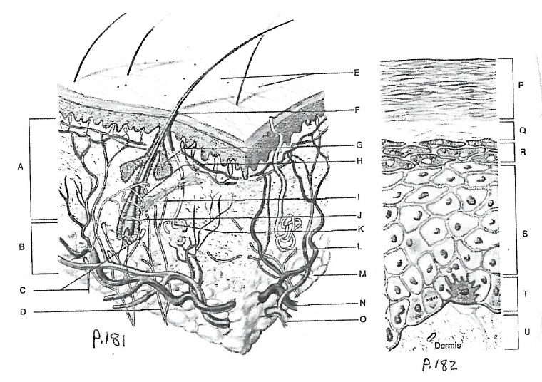

_____ 1. Produces most sweat when we exercise.

_____ 2. Gives off dander.

_____ 3. Produces glycolipids that waterproof the skin.

_____ 4. Contains melanocytes, Merkel cells, and keratinocytes.

_____ 5. Holocrine glands that secrete contents of broken-down cells.

_____ 6. Causes hair to move within the skin in response to stimuli.

_____ 7. Region containing most glands.

_____ 8. Especially abundant in the groin and axillary regions.

_____ 9. Present only in thick skin where keratinocytes are densely packed with eleidin.

_____ 10. Home of dendritic cells which protect against infections.