**Chapter 7 Study Guide: Bone Tissue & Physiology Name ____________________**

1. **Short Answer**
2. Bone tissue is also called _______________ tissue.
3. The skull, spinal column, and thoracic cage make up the ___________ division of the skeleton.
4. By shape, most cranial bones, the sternum, and the scapulae are classified as _________ bones.
5. ________ bone forms the surface of all bones and _________ bone is found within the heads of long bones and bodies of all vertebrae.
6. In life, a bone is covered with a very tough fibrous sheath called the _______________.
7. The bone-forming cells that synthesize its matrix and later become trapped in it are called ____.
8. Most lamellae of compact bone are concentrically arranged around a space called the ________.
9. Blood is produced in a tissue of the skeletal system called the ___________________.
10. Most of the bones of the embryo develop from cartilage models by a process called _________.
11. The growth zone of a child’s femur – a cartilage plate between the epiphysis and diaphysis – is called the _____________________.
12. The most common adult bone disease, especially among postmenopausal white women is ____.
13. **Matching**
14. **intramembranous G. osteogenic M. osteoclasts S. blood vessels**
15. **medullary cavity H. osteocytes N. periosteum T. monocytes**
16. **diaphysis I. sesamoid bones O. Haversian canal U. articular cartilage**
17. **lymphocytes J. red blood cells P. symphysis V. endochondral**
18. **chondrocytes K. osteogenic cells Q. sutural W. periosteum**
19. **osteoblasts L. epiphyses R. hemopoietic X. lacunae**

_____ 1. Occupy the lacunae of compact bone.

_____ 2. Bones that develop within the tendons some time after birth.

_____ 3. Region of long bone made of compact bone with a central medullary cavity.

_____ 4. Layer of hyaline cartilage on the end of a long bone.

_____ 5. Bone-dissolving macrophages with ruffled borders.

_____ 6. Blood cells from which the cells in question 5 develop.

_____ 7. Contain the nearest blood vessels to most osteocytes in compact bone.

_____ 8. Describes the function of red bone marrow.

_____ 9. Type of ossification that produces the flat cranial bones.

1. **True or False (if false, cross out the incorrect portion and write in the correction).**
2. Without medical care a person could not live for more than a few days without parathyroid glands.

1. Bones attain their final mass, size and shape at the end of adolescence.
2. The majority of bones are in the appendicular skeleton.
3. The epiphyseal plate is the primary site of bone growth in people of all ages.
4. Spongy bone consists of a random array of calcified trabeculae, like the fibers of a sponge.
5. Calcium is not deposited in osseous tissue unless there is also a proportionate amount of phosphate present in the blood.
6. Some bones are formed by both endochondral and intramembranous ossification.
7. A deficiency of vitamin D will almost certainly lead to hypocalcemia.
8. Yellow bone marrow can change into hemopoietic tissue when necessary.
9. **Multiple Choice**

_____ 1. Hypocalcemia causes:

1. diarrhea D. hypercalcemia
2. sluggishness E. sensitivity in nerve/muscles
3. changes in phosphate concentrations

_____ 2. During ossification of the humerus, ______ hypertrophy and die.

1. osteocytes D. chondrocytes
2. osteogenic cells E. chondroblasts
3. osteoblasts

_____ 3. The patella is an example of a(n) _____________ bone:

1. wormian D. endochondral
2. long E. sutural
3. sesamoid

_____ 4. The skeletal system serves all of the following functions ***except*** ______________.

1. acid-base homeostasis D. hormone secretion
2. electrolyte homeostasis E. protection
3. blood formation

_____ 5. The process in which hyaline cartilage is converted to bone is called _____ ossification.

1. interstitial D. appositional
2. epiphyseal E. endochondral
3. intramembranous

_____ 6. A rough area on a bone, usually serving for muscle attachment, is called a(n):

1. fossa D. facet
2. tuberosity E. sulcus
3. alveolus

_____ 7. The diaphysis of a 35-year-old’s femur is filled with:

1. yellow marrow D. endosteum
2. red marrow E. spongy bone
3. diploe

_____ 8. Tetany, laryngospasm, and suffocation could result from:

1. osteoporosis D. hypercalcemia
2. lack of parathyroid hormone E. osteomalacia
3. lack of calcitonin

_____ 9. A healing fracture exhibits, at one stage, a _______ containing collagen and fibrocartilage.

1. soft callus D. chondrosarcoma
2. hard callus E. osteoma
3. hematoma

_____ 10. The carpals are bones of the:

1. cranium D. thoracic cage
2. feet E. wrist
3. ankles

_____ 11. The head of a long bone is called the:

1. metaphysis D. epiphysis
2. trabeculae E. epicondyle
3. trochanter

_____ 12. The fusion of blood monocytes gives rise to:

1. chondrocytes D. osteogenic cells
2. osteocytes E. osteoblasts
3. osteoclasts

_____ 13. Blood vessels of the periosteum enter the bone matrix by way of:

1. central canals D. fossae
2. perforating canals E. the medullary cavity
3. canaliculi

_____ 14. Which of these is/are true about bone shapes?

1. Flat bones normally protect organs beneath them.
2. Carpals and tarsals are considered to be flat bones.
3. Long bones contain both compact and spongy bone
4. Vertebrae are classified as short bones.
5. 1 & 3 D. 4 only
6. 2 & 4 E. All of the above
7. 1, 2, & 3

_____ 15. Which of these is/are true about bone structure?

1. Bone matrix contains proteins like collagen that provide flexibility.
2. Bone contains both organic and inorganic components.
3. In most bones the epiphyses are wider than the diaphysis and are places for muscle attachment.
4. Most of the inorganic mineral in bone matrix is calcium carbonate.
5. 1 & 3 D. 4 only
6. 2 & 4 E. All of the above
7. 1, 2, & 3

_____ 16. Which of these is/are true about bone cells?

1. Osteoblasts deposit the organic components of bone.
2. Osteoclasts are isolated in lacunae in mature compact bone.
3. Osteocytes do not produce bone matrix.
4. Osteoporosis is caused by the presence of too many osteoclasts.
5. 1 & 3 D. 4 only
6. 2 & 4 E. All of the above
7. 1, 2, & 3

_____ 17. Which of these is/are true about conditions that affect the skeleton?

1. In achondroplastic dwarfism, the skeleton remains cartilaginous indefinitely.
2. Carpopedal spasms can be a sign of hypercalcemia.
3. Colles fractures are common among athletes.
4. Osteogenic sarcoma is the most deadly form of bone cancer and affects males more than females.
5. 1 & 3 D. 4 only
6. 2 & 4 E. All of the above
7. 1, 2, & 3

_____ 18. Which of these is/are true about osteoporosis?

1. It is the most common bone disease.
2. Both males and females suffer from it.
3. It involves a decrease in bone mass, especially in spongy bone.
4. Risk factors include gender, age, smoking, poor nutrition, and being sedentary.
5. 1 & 3 D. 4 only
6. 2 & 4 E. All of the above
7. 1, 2, & 3

**E. Word Origins: Identify the meaning of the portion of the words in their context or as a pre/suffix.**

1. In the word **osteocyte**, *osteo* means ________________________.

2. In the word **sesamoid**, *oid* means ____________________ _____.

3. In the word **diaphysis**, *physis* means _________________________.

4. In the word **osteoclast**, *clast* means ___________________.

5. In the word **hemopoietic**, *poietic* means ________________________.

6. In the word **ectopic**, *top* means ______________________.

7. In the word **achondroplastic**, *a* means _______________________.

8. In the word **hypocalcemia**, *emia* means ___________________.

9. In the word **hypocalcemia**, *calc* means ___________________________________.

10. In the word **orthopedics**, *ortho* means ________________________________.

11. -blast means _________________________________.

12. epi- means _________________________________.

13. -icul means _______________________________.

14. peri- means ______________________________.

15. chondri- means ____________________________.

**F. Which One Does Not Belong? Identify which option does NOT fit with the others, then write a SHORT explanation of why. There may be a couple of acceptable answers, depending on your reply.**

1. a) osteocyte b) osteoid c) osteoclast d) osteoblast

2. a) ulna b) talus c) tibia d) radius

3. a) Colles b) spiral c) comminuted d) straight

4. a) bony collar formation b) soft callus formation c) hematoma formation d) granulation tissue formation

**G. Figure Exercise: Label each structure on the diagram and select the most appropriate answer.**

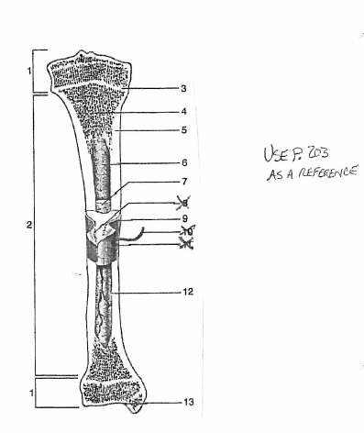

_____ 1. _________ is the remnant of the region of growth in length in children.

1. 1 D. 6
2. 3 E. 13
3. 5

_____ 2. __________ contains red, yellow, or gelatinous marrow depending on age.

1. 1 D. 9
2. 4 E. 11
3. 6

_____ 3. __________ is made of hyaline cartilage.

1. 13 D. 6
2. 1, 3 E. 10
3. 2, 12

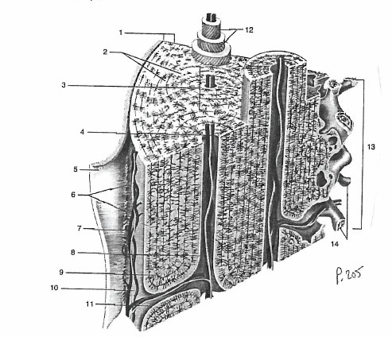

_____ 4. Which of these house living bone cells?

1. 3 D. 9
2. 4 E. 11
3. 7

_____ 5. Number 3 is the structural unit of ___________ bone.

1. spongy D. epiphyseal
2. long E. adolescent
3. compact

_____ 6. Number 5 contains ___________________.

1. osteocytes D. lacunae
2. blood vessels E. perforating canals
3. osteoblasts

_____ 7. Osteogenic cells can be found in:

1. 4, 5, 8 D. 1, 3, 4
2. 5, 6, 12 E. 4, 5, 6
3. 5, 9, 11

_____ 8. The structures shown in number 14 are called:

1. osteons D. lamellae
2. trabeculae E. lacunae
3. perforating fibers

_____ 9. The function of number 12 is to:

1. increase the surface area for hydroxyapatite deposition.
2. increase the number of osteocytes in bone.
3. decrease the tension on bone.
4. increase the strength of bone.
5. make bone more flexible.