Name Date Class

INTERPRETING GRAPHICS
Use with Section 14.3

Determination of the Molar Mass of a Volatile Liquid
 | Trial 1 | Trial 2
Mass of flask + stopper | 83.32 g | 83.39 g
Mass of flask + stopper + condensed vapor | 83.73 g | 83.82 g
Temperature of boiling water | 99.0ºC | 99.0ºC
Barometric Pressure | 773.5 mm Hg | 812.0 mm Hg

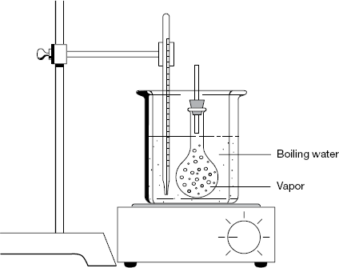

You can use the ideal gas law to determine the molar mass of a liquid. Using the setup shown, a student added a small volume of an unknown liquid to a round-bottom flask, which can hold 267 mL of water. The flask was then submerged in a hot-water bath to completely vaporize all of the liquid. As the vapor forms, any excess vapor escapes through the top of the flask. Next, the flask was cooled to condense the vapor in the flask. Then the mass of the flask and condensed vapor was determined. Use the data in the table to answer the following questions.

1. What is the mass of the condensed vapor?

a. Trial 1

b. Trial 2

Chapter 14 The Behavior of Gases 357

Name Date Class

2. What is the volume of the vapor in each trial?

3. What is the temperature of the vapor in kelvins?

a. Trial 1

b. Trial 2

4. What is the pressure of the vapor in kPa?

a. Trial 1

b. Trial 2

5. Calculate the number of moles of condensed vapor.

a. Trial 1

b. Trial 2

6. Calculate the molar mass of the volatile liquid.

a. Trial 1

b. Trial 2

7. Average the two molar masses.

8. If the unknown liquid is composed of carbon, hydrogen, and oxygen, write one possible molecular formula for this substance.

358 Core Teaching Resources

