Register and Pay for an AP Exam.

How do I register and pay for an AP Exam?

There is a two-step process to register for AP exams.

Step 1 - students must log-in or create a MyAP account in CollegeBoard. Students complete this step in their AP class (typically). **Please register using a personal email**
Step 2 - the Payment Process - Century High School utilizes Total Registration (hyperlink or type in this address https://user.totalregistration.net/AP/350159) to collect student payments. Students need to create an account if they have not previously done so, or log-in to an existing Total Registration account.
Students will pay for all AP exams online with credit/debit, or by mailing a check to Total Registration, LLC. If you are not requesting any of the waivers explained below, you can pay online right away. More information will be provided as you complete the registration process on Total Registration.
If you have requested the state subsidy waiver or the free/reduced lunch waiver, you will need to wait for waiver approval in order to calculate your final amount due. This may take up to a few days. Once your request has been reviewed, you will receive an email (to the email address provided during the exam registration process) indicating your final bill total along with instructions on how to pay for your AP exam(s) within your Total Registration account.

What is Total Registration and why does CHS use it for AP Exam registration?

Total Registration is a company that provides exam registration and payment services to high schools throughout the country. Total Registration helps improve order accuracy and registration efficiency for involved staff at CHS.

Do I register for each exam separately or can I place one order for all my AP exams?

You place one order for all your AP exams.

What is the cost of the AP exam?

The cost for each AP exam this school year is $103.00. This includes a $3.00 fee per exam that covers the costs of exam administration at Century High School.

What is the state subsidy and how can I use it to waive my AP exam fees?

The state subsidizes AP Exam fees in the areas of Math, Science, and English. Covered AP Exams include
Biology, Chemistry, Physics, Calculus AB, Calculus BC, Environmental Science, Statistics, English Language & Composition, and English Literature & Composition.

How do I apply for the waiver?

You must answer "Yes" to the question "WAIVER ELIGIBILITY: Are you taking any AP exams in: Biology, Calculus AB, Calculus BC, Chemistry, Computer Science A, Computer Science Principles, English Language, English Literature, Physics, or Statistics? (NOTE: You may be eligible for reduced exam fees based on how many exams you have taken in your lifetime)."
When you answer "Yes," you will be placed in a queue where CHS staff will approve/deny requests based on whether the selected exam is eligible for the waiver. The waiver amount will then be entered for each of the exams requested. This process can take anywhere from a few hours to a few days, so thank you for your patience!


What does the AP exam cost for a student on free or reduced lunch?

Advanced Placement reduces the cost of AP exams to $57.00 for students who are part of the Federal Free or Reduced-Price Lunch Program. That fee applies to exams in Art, Psychology, United States Government & Politics, and United States History.
For those taking exams in the areas covered by the state subsidy (math, science, and English; see information above) students can receive 4 free exams (lifetime count).

The tables below breakdown down the AP exam costs based on the information shared above

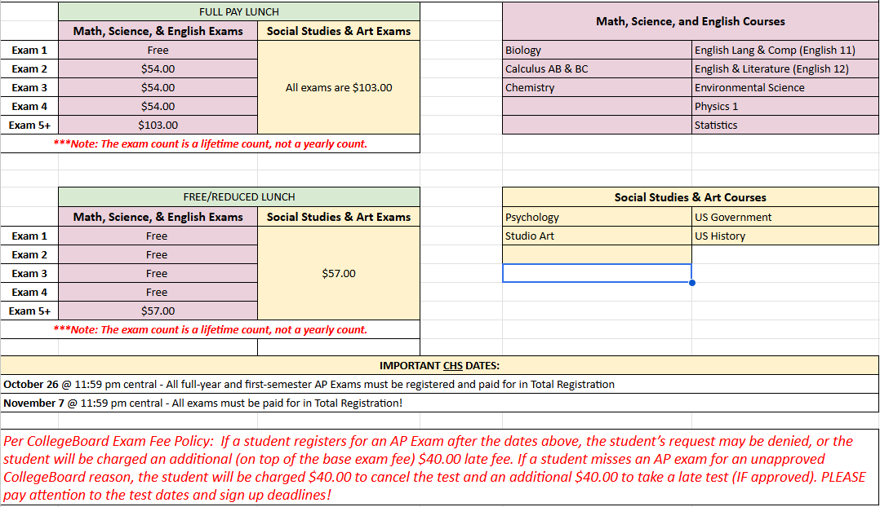

Additional Fees:

If you sign up after the registration deadline, you will be charged an additional $40.00 late fee, and your request may be denied. If you miss your test for an unapproved CollegeBoard reason, you will be charged $40.00 to cancel the test and an additional $40.00 to take a late test IF approved. PLEASE pay attention to the test dates and sign-up deadlines!

If you have further questions about the AP Exam registration, please contact Mrs. Lindsey Guidinger via email lindsey_guidinger@bismarckschools.org or by phone 323-4900

